

Presented

By:

SAHIL

Opportunity Analysis of a Major

Food and Beverage

Manufacturer



2

Outline

•

Case Statement

•

Analysis of data

i.

Analysis Of Restaurants

Spends

&

Share

ii.

Opportunities In Non

-

commercial

Establishments

iii.

Getting A View Of Retailer

Stores

•

Summary

•

Conclusion



•

Get

a

quick

view

of

the

share

of

F&B

spending

from

existing

customers

restaurants

(

)

that

my

company

is

getting,

and

if

there

are

any

opportunities

in

specific

segments

.

•

What

are

the

adjacent

opportunities

from

the

non

-

commercial

establishments

to

additionally

sell

into

note

(

that

there

are

no

customers

currently

in

the

non

-

commercial

segment

)

.

Their

data

of

spending

are

not

available,

so

will

be

interested

in

knowing

relevant

proxies

that

could

indicate

opportunities

for

us

.

•

Retailers

are

a

different

business

division

and

out

of

scope

for

me

(

Shaun),

but

some

of

my

customers/prospects

could

be

buying

from

these

retailers

–

so

getting

a

view

of

retailer

presence

adjacent

to

his

customers

&

prospects

will

help

understand

how

much

of

these

opportunities

are

being

met

/

unmet

.

Case Statement

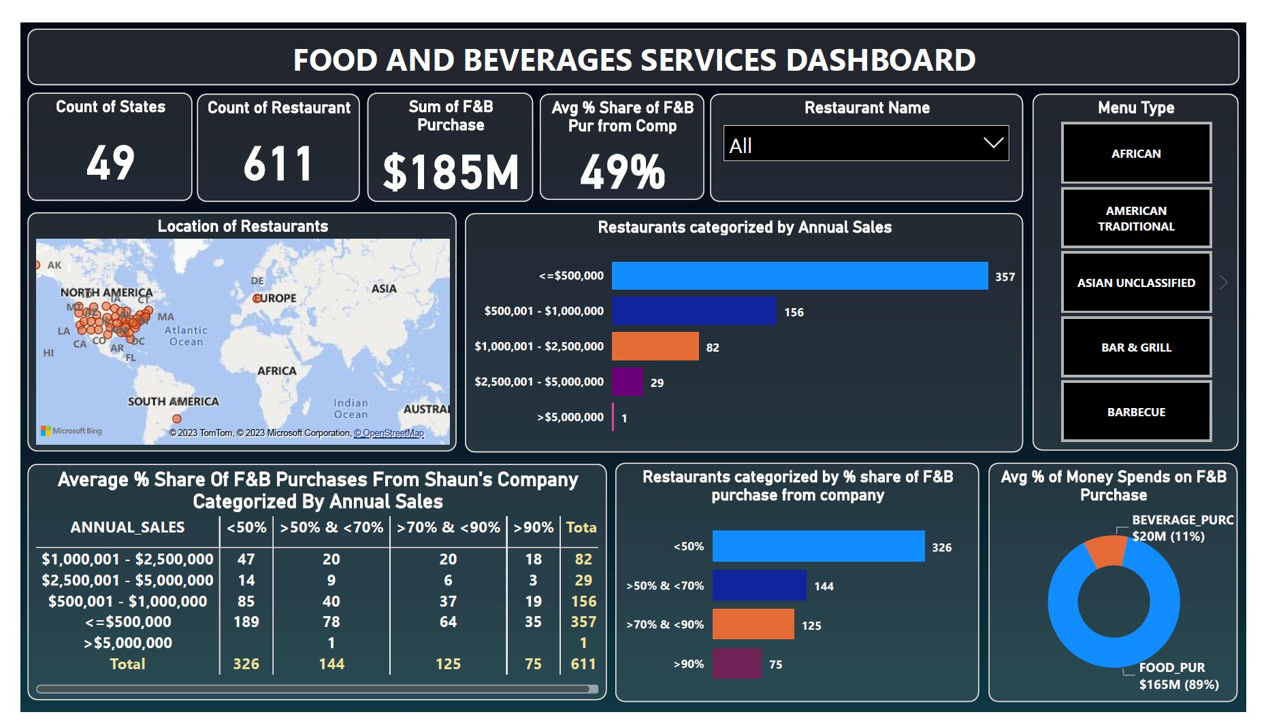



Insights

&

Opportunities

:

•

There

are

611

unique

restaurants

which

are

segregated

based

on

annual

sales

and

also

their

percentage

share

of

F&B

purchases

from

Shaun's

company

as

below

;

•

According

to

the

analysis,

Shaun's

company

has

good

relationships

with

restaurants

that

generate

sales

revenues

of

around

<

$

500

,

000

.

Analysis

Of

Customer’s Annual

Sales

and %

Share

O

f

F&B

Purchases

F

rom

Shaun's Company

Less than 50% share

⇒

Needs to be worked on

Greater than 50% but less than 70%

⇒

Needs to be worked on

Greater than 70% but less than 90%

⇒

Have to improve business relations

Greater than 90% share

⇒

High

Business

with

them,

need

to

maintain

the

same

level

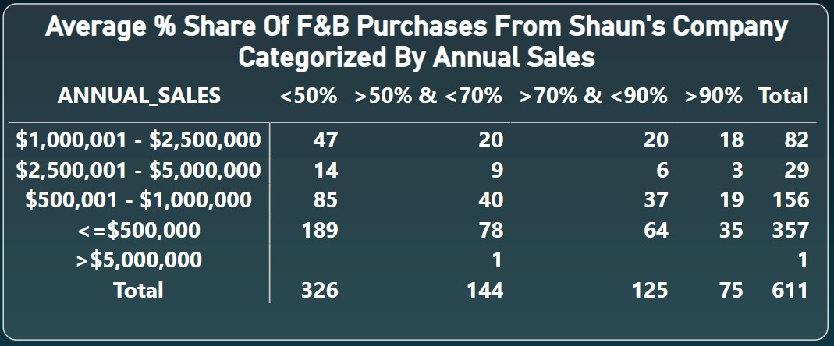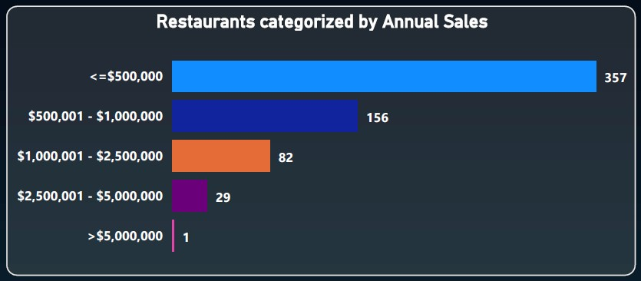

Insights

&

Opportunities

:

•

The

above

-

clustered

column

chart

is

categorized

based

on

the

top

5

Simplified

Menus

available

in

restaurants,

indicating

that

most

of

the

restaurants

make

a

maximum

annual

sales

of

<=

$

500

,

000

by

selling

these

Simplified

Menus

.

•

The

donut

plot

represents

the

total

sun

money

spent

on

the

F&B

purchases,

indicating

the

restaurants

spent

the

maximum

amount

of

the

money

to

purchase

food

∽

$

165

M

(

89

%

)

while

for

beverages

they

spent

∽

$

20

M

(

11

%

)

.

Analysis

Of

Customer’s Annual

Sales Based On Simplified Menu

and Average % Money Spent On F&B Purchase

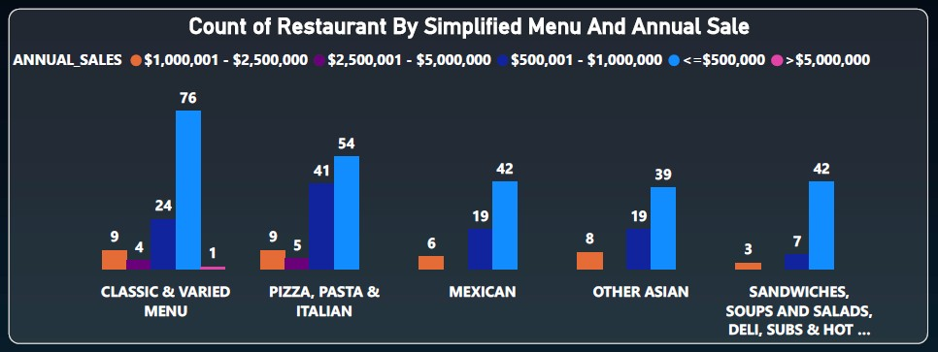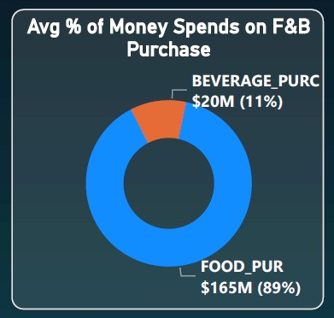

Insights

&

Opportunities

:

•

No

data

on

states

were

provided

other

than

MA

(

Massachusetts

)

.

Therefore,

the

analysis

was

only

done

based

on

a

dataset

of

state

-

MA

.

•

The

number

of

schools

ranges

from

3

–

5

,

6

–

9

and

<=

10

offered

a

maximum

number

of

meals

in

a

day

such

as

>

2000

and

between

1001

-

2000

.

O

pportunities

A

vailable In Non

-

commercial Establishments

)

Number Of Meals Provided By Schools

(

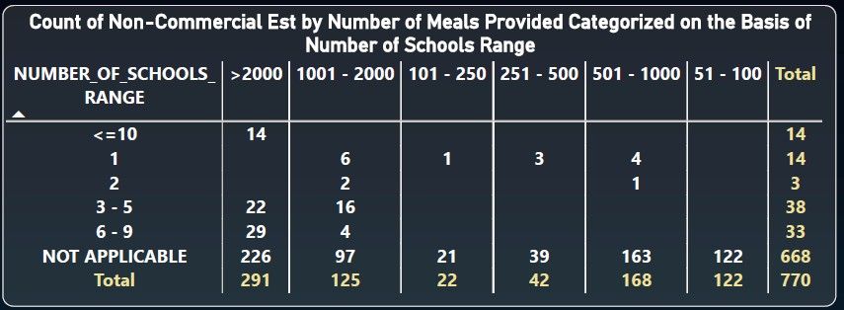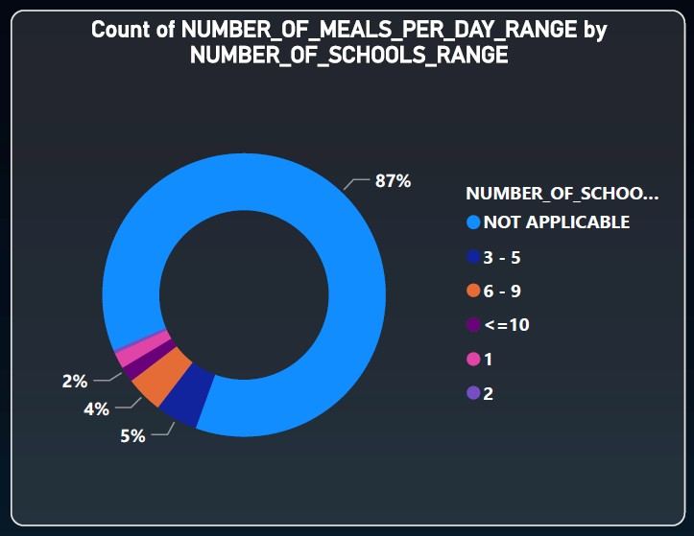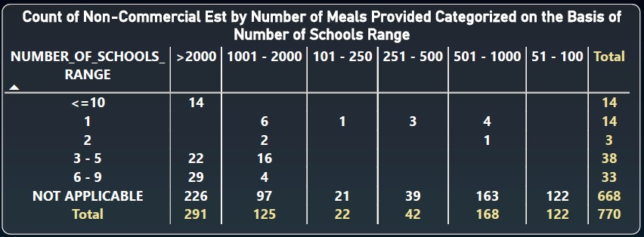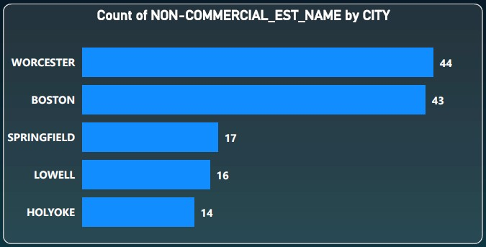

Insights

&

Opportunities

:

•

No

data

on

states

were

provided

other

than

MA

(

Massachusetts

)

.

Therefore,

the

analysis

was

only

done

based

on

a

dataset

of

state

-

MA

.

•

The

number

of

schools

ranges

from

3

–

5

,

6

–

9

and

<=

10

offered

a

maximum

number

of

meals

in

a

day

such

as

>

2000

and

between

1001

-

2000

.

•

Out

of

770

unique

non

-

commercial

establishments

,

most

of

them

are

located

in

Worcester

(

44

)

and

Boston

(

43

)

city

.

O

pportunities

A

vailable In Non

-

commercial Establishments

Number Of Meals Provided By Schools

)

(



Opportunities Available In Non

-

commercial Establishments

(

Capacity Beds Range Categorized

Based On

Ownership Type)

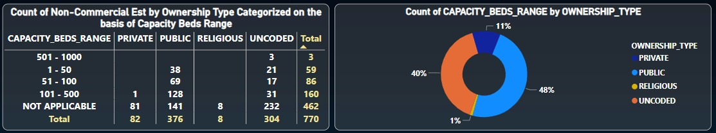

Insights

&

Opportunities

:

•

The

non

-

commercial

establishments

such

as

the

hospitals

having

Ownership

type

‘

Public

’

has

the

maximum

number

of

available

beds

ranging

from

1

-

50

,

51

–

100

and

101

–

500

(

which

is

48

%

of

all

type

of

ownership)

.



Opportunities Available In Non

-

commercial Establishments

(

Operation Type

Categorized

Based On Ownership

Type)

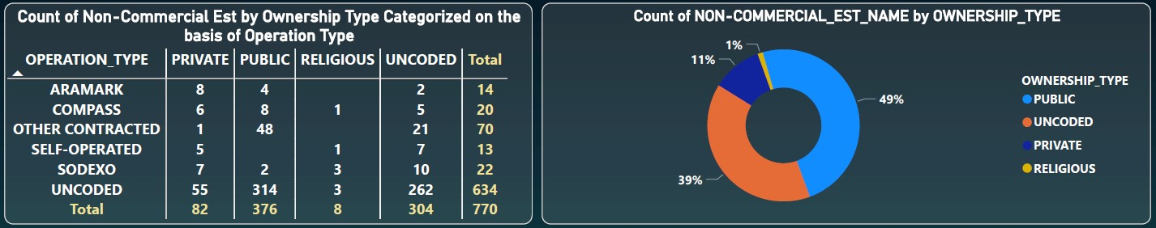

Insights

&

Opportunities

:

•

The

non

-

commercial

establishments

such

as

the

hospitals

having

Ownership

type

‘

Public

’

has

the

maximum

number

of

available

beds

ranging

from

1

-

50

,

51

–

100

and

101

–

500

(

which

is

48

%

of

all

type

of

ownership)

.

•

Most

of

the

public

ownership

of

the

non

-

commercial

establishments

is

operated

on

a

contracted

basis

(

which

is

49

%

of

all

types

of

ownership)

.



Analysis

O

f

R

etail Store’s Annual Sale Based On Market

Segment

Insights

&

Opportunities

:

•

According

to

the

analysis,

based

on

market

segment

,

out

of

601

retailer

stores

most

of

them

(

308

stores)

generate

sales

revenues

of

around

<=

$

500

,

000

.

•

Retail

stores

such

as

Grocery,

Liquor,

and

Convenience

stores

have

the

maximum

contribution

in

the

annual

sale

of

<=

$

500

,

000

.

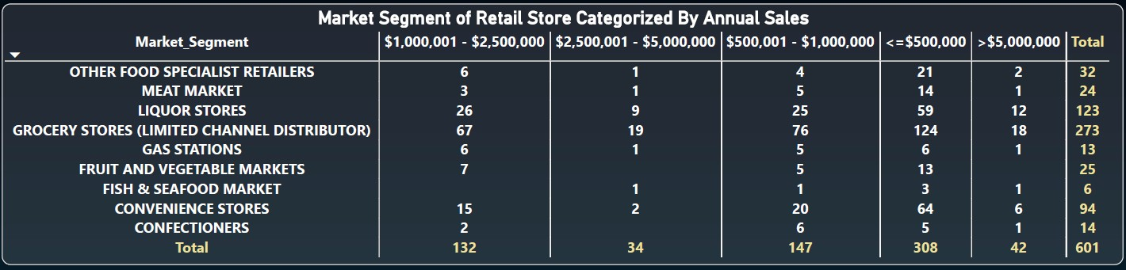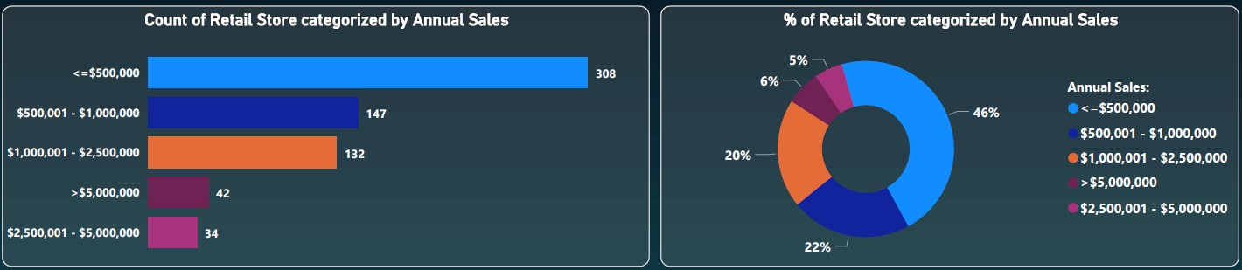

Analysis

O

f

R

etail Store’s Annual Sale Based On Market

Segment and % Of Retailer Store categorized By Annual Sale

Insights

&

Opportunities

:

•

According

to

the

analysis,

based

on

market

segment

,

out

of

601

retailer

stores,

most

of

them

generate

sales

revenues

of

around

<=

$

500

,

000

.

•

Retail

stores

such

as

Grocery,

Liquor,

and

Convenience

stores

have

the

maximum

contribution

in

the

annual

sale

of

<=

$

500

,

000

.

•

Out

of

601

retail

stores,

46

%

of

them

make

revenues

of

sale

<=

$

500

,

000

and

22

%

of

the

stores

make

between

<=

$

500

,

001

-

$

1

,

000

,

000

.



Insights

&

Opportunities

:

•

The

data

of

only

three

states

are

available

;

CT

(

Connecticut

)

,

KY

(

)

Kentucky

and

MA

(

Massachusetts

)

.

Therefore

,

the

analysis

was

only

done

based

on

a

dataset

of

these

states

.

•

Based

on

the

market

segment,

most

of

the

retail

stores

are

located

in

the

state

of

KY

)

(

Kentucky

which

is

519

(

88

%

)

out

of

661

.

•

In

the

state

of

KY,

259

retail

stores

generate

sales

revenue

of

<=

$

500

,

000

which

is

comparatively

larger

than

the

states

of

CT

and

MA

.

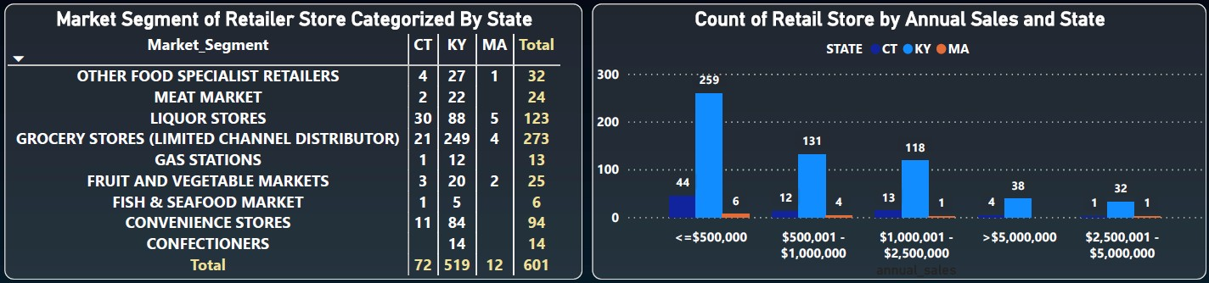

Analysis

Of

Retail Stores Located

In

different States Categorized

Based On

Market Segment



Analysis Of Retail Stores

Categorized

Based On Market

Segment

And % Retail Stores Located

I

n States

Insights

&

Opportunities

:

•

Based

on

the

analysis,

88

%

of

retail

stores

are

located

in

the

state

of

KY

.

•

Most

of

them

are

grocery

stores

(

249

)

,

Liquor

stores

(

88

)

and

convenience

stores

(

84

)

.

